
Academic Grant Program

Proposal Template

Proposal Requirements
- Final document: save as a single PDF and upload to submission site
- Formatting: 11-point font (e.g., Arial, Calibri, Times New Roman) with 1-inch margins, single spaced
- Length: maximum four pages, including images and figures, but excluding appendices
- Each person can submit one proposal per quarter, a maximum of four proposals annually. For example, one submission is allowed in the first quarter, January-March.
- Each individual applicant is eligible to receive one award per calendar year.
- Proposals that do not adhere to the template formatting and content requirements will be declined.

Project Title
Project Name:

Principal Investigator Information
Name:
Title/Role:
University Name (full name, no acronyms):

Project Collaborators (optional, maximum 2)
Research Team Member Name:
Title/Role:
University Name (full name, no acronyms):

NVIDIA Contact (optional)
- Name:
- Email:
- Describe your relationship with this contact (one sentence):

Abstract
Up to 300 words

Project Keywords
Up to five

NVIDIA Platforms
List the software and hardware you will use. Explain what steps you will take to adopt (if new user) and/or your experience with each.

Dataset and Model (if applicable)
Share details about the size, type, and location of data:
- Number of TBs:
- Data type (video, LiDAR, voice, text, etc.):
- Collected in house or open source:
- Confidential, or with personal data (describe restrictions; data that requires an NDA is not permitted):
- Approximate number of parameters (for custom or foundation AI models):
- Geographic location where the data is stored:

Introduction
Describe what you will do. Tell us why it matters. If this project will be the first to do something, explain why that something is needed.

Continued on next page

Methods
Describe the technical approach. Include details like algorithms and programming language(s) used and how NVIDIA hardware and software will help.

Expected Results
Provide a timeline with project milestones, details about when and how NVIDIA cloud resources, hardware, and software will be used, and projected outcomes (e.g., publication planned, conference submission, open-source code). The timeline should be broken down by month. Be mindful of the CFP decision date and the GPU hours dates if requesting cloud. Share whether the success of the project is conditional on other grants or donations.

Project Support Details
Provide justification for the resources requested. If requesting cloud, include a calculation of the GPU hours needed for each stage of the project. If requesting physical hardware, explain why cloud compute cannot be used and how much physical hardware is required to advance the project.

Refer to the specific CFP to see the amount and type of resources available. Proposals that request above the stated maximums will be declined.

- Hours in the cloud needed* (32k hours maximum):
- Number of concurrent GPUs needed (8 maximum):
- Amount of cloud storage needed (32TB maximum):
- Physical hardware needed (type/quantity):

*Assume A100 80GB. Note one hour on a 4X.A100 instance = 4 GPU hours

Cloud Readiness
Fill out this section only if requesting cloud resources.
Describe the operating system your development environment or application runs on. Cloud servers run on Ubuntu Linux. NVIDIA cannot be responsible for setting up your experiment or tests.
Include what your first few activities will be if given a cloud GPU server. Note your experience with these activities:
- Importing your data (pulling down from another site)
- Installing dependencies (e.g., pip)
- Installing and executing code base at the command line
- Backing up any intermediate results, as clouds may be ephemeral
- Installing and integrating CUDA® and other NVIDIA SDKs
- Building and running containers

Continue to final page

Appendix A – Previous Collaboration with NVIDIA
(One page maximum, optional)
Describe when and how you may have worked with NVIDIA (e.g., received hardware donation, used teaching kits, certified as DLI ambassador, etc.). Include the names and emails of NVIDIA collaborators. Provide a brief summary of the results: papers published, number of courses, and students taught.

Appendix B – CV(s)
(One page maximum for each project collaborator, required) CV with the most relevant publications to the proposal

Appendix C – Citations
(One page maximum, optional)

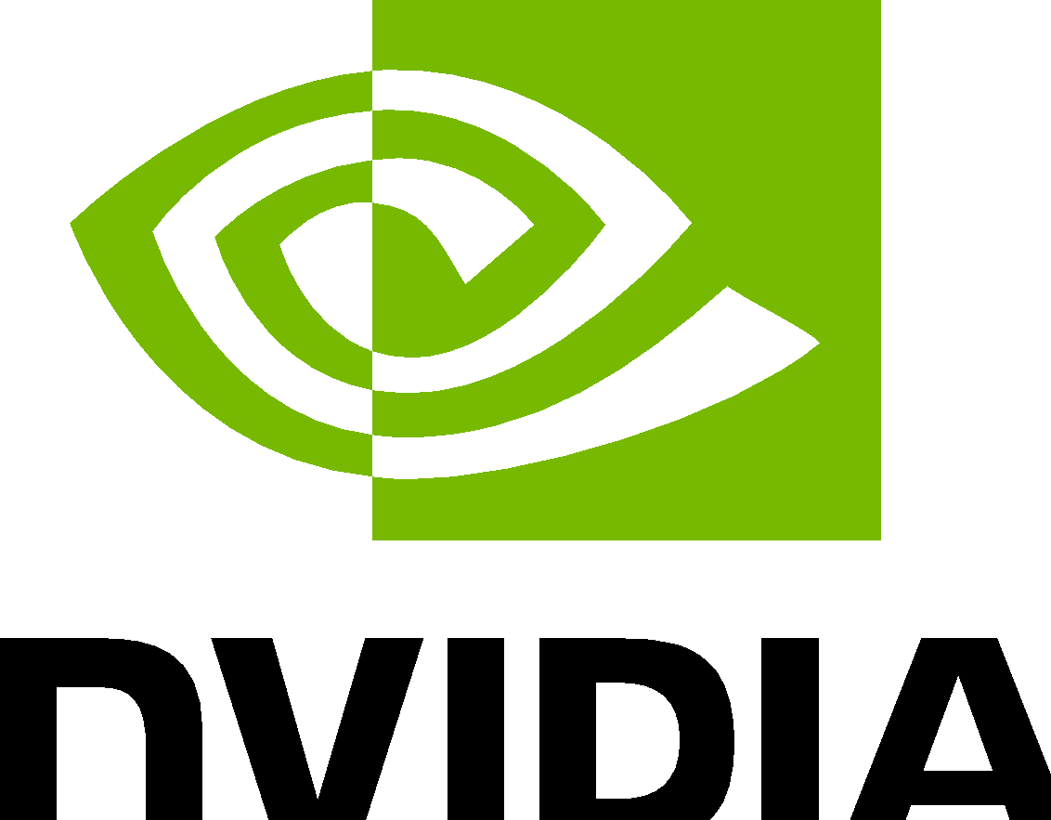
Please review NVIDIA Academic Grant Program terms and conditions.

© 2025 NVIDIA Corporation. All rights reserved. NVIDIA, the NVIDIA logo, and CUDA are trademarks and/or registered trademarks of NVIDIA Corporation in the U.S. and other countries. Other company and product names may be trademarks of the respective companies with which they are associated. All other trademarks are property of their respective owners. 4270450.OCT25

